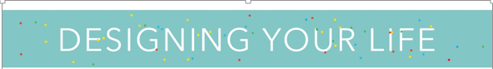

**Odyssey plan exercise.**

***2 different versions of your next ten years***

***“Designers don’t think their way forward. Designers build their way forward.”***

We often believe that we only have one life ahead of us. The authors of *Designing your Life* state “There is no one idea for your life, there are many lives you could live happily and productively” This enables you to explore different paths, before committing to a single one. The theory behind future scenarios says that there’s no such thing as a single future, but many possibilities that might unfold.”

**The Odyssey Plan** allows you to plan a graphic representation of multiple paths you could follow for your future. In this exercise we are asking you to plan two possible alternative lives you might live over the next ten years.

1. **Plan A** -Your first Odyssey plan should be the development of your life that is already in route. A plan that is already something you have begun to map out in your mind. This plan should include the following three components: your *Career* plans ( eg I want to become a corporate lawyer), *Social life* plan ( eg getting married) and *Lifestyle* plans (eg leisure -complete a marathon or travel to the Himalayas- where do I want to live, what do I want to own eg a house). This plan is for the next 10 years with incremental goals every 2 years. Start by listing your goals in 10 years at the bottom right corner of the form. Also, complete the rating (by placing an arrow or X) on the four dials.
   1. *Resources*- do you have financial and personal resources to complete this plan.
   2. *I Like it*- how desirable is this plan to you.
   3. *Confidence*- how certain are you that you can complete this plan.
   4. *Coherence*- how much is this plan a representation of your personal characteristics eg. Personality and strengths and weaknesses.

**Plan B-** is more inventive alternative for your next 10 years. Often plan A is more about what your social constraints dictate ( eg family or socioeconomic forces) but not about what inspires you. Using the same format imagine a plan where you have no restrictions, eg money, time and people wouldn’t laugh, what would you do them?

1. **ere**
2. 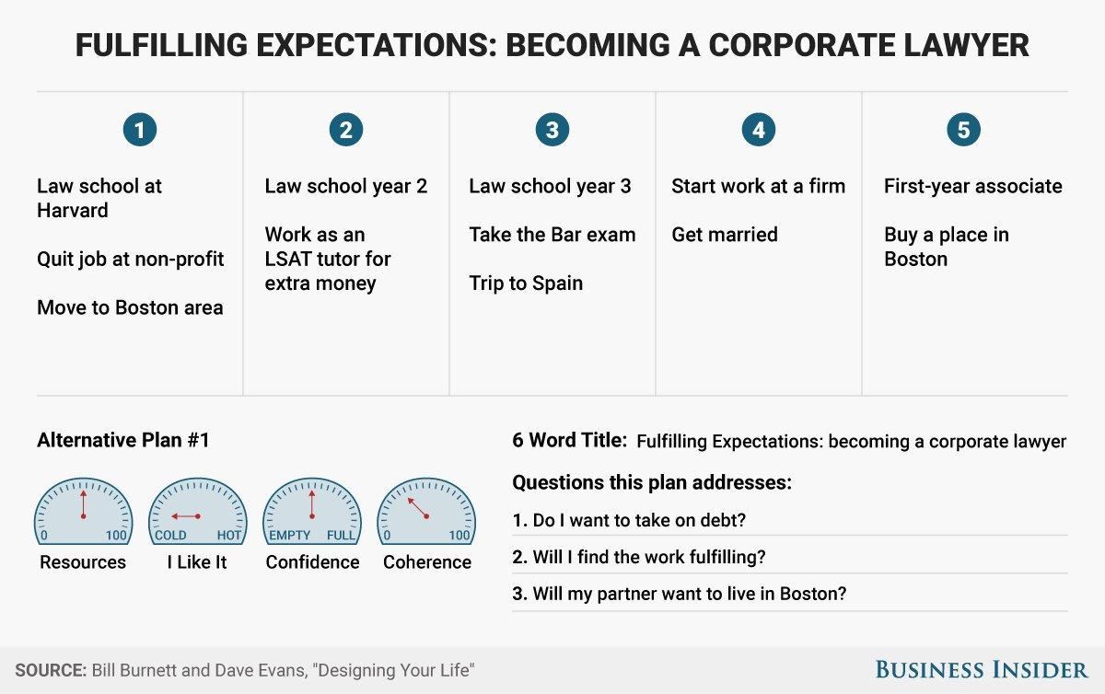

|  |  |  |  |  |  |
| --- | --- | --- | --- | --- | --- |
| **1st year** | **3rd year** | **5th year** | **7th year** | | **10th year** |
| **Career plan** | **Career plan** | **Career plan** | **Career plan** | | **Career plan** |
| **Social plan** | **Social plan** | **Social plan** | **Social plan** | | **Social plan** |
| **Lyfestyle**  **plan** | **Lyfestyle plan** | **Lyfestyle plan** | **Lyfestyle plan** | | **Lyfestyle plan** |
|  | | | | **Primary Goal**  **Career:**  **Social:**  **Lifestyle:**  **Questions this plan answers**  **1.**  **2.**  **3.** | |

**Plan A**

**Title of occupation**:

|  |  |  |  |  |  |
| --- | --- | --- | --- | --- | --- |
| **1st year** | **3rd year** | **5th year** | **7th year** | | **10th year** |
| **Career plan** | **Career plan** | **Career plan** | **Career plan** | | **Career plan** |
| **Social plan** | **Social plan** | **Social plan** | **Social plan** | | **Social plan** |
| **Lyfestyle**  **plan** | **Lyfestyle plan** | **Lyfestyle plan** | **Lyfestyle plan** | | **Lyfestyle plan** |
|  | | | | **Primary Goal**  **Career:**  **Social:**  **Lifestyle:**  **Questions this plan answers**  **1.**  **2.**  **3.** | |

**Plan B**

**Title of occupation**: